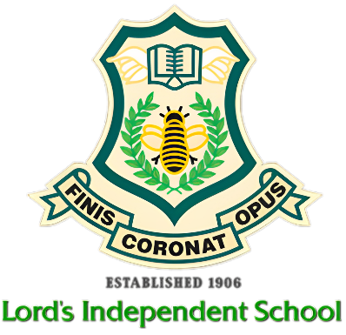

06 March 2024

Dear Parents / Carers
I hope this letter finds you well. As we continuously strive to provide the best learning environment for our students at Lord's School, I writing to address an issue that has become prevalent in recent times - the use of mobile phones during school hours. We value the importance of communication and understand that mobile phones can be a useful tool for keeping in touch with your child; however, the use of mobile phones during school hours can be disruptive to the learning process and can have a negative impact on your child's academic progress.
To ensure a focused and conducive learning environment for all students, we kindly request that mobile phones be switched off and kept in the locker provided out of sight during school hours. If the phone is found in their possession and not put away in the locker it will be confiscated, and a parent or carer will be called in to collect it. They will be allowed their phone during lunch time, however, if the disruption continues, we will enforce a blanket ban on the use of mobile during school hours.
All communications with your child during this time should be made through the school office. In cases of emergency, please feel free to contact the school office and we will ensure that the message is delivered promptly.
We believe that limiting the use of mobile phones during school hours will encourage students to engage more fully with their studies and will contribute to a positive and productive learning environment. We ask for your support and cooperation in implementing this policy. We appreciate your understanding and cooperation in this matter, and we are confident that together we can create an environment that promotes effective learning and well-being for all our students.
Thank you for your continued support in ensuring the best educational experience for your child.
Yours sincerely,
Z Ghanchi
Z Ghanchi
Head Teacher

